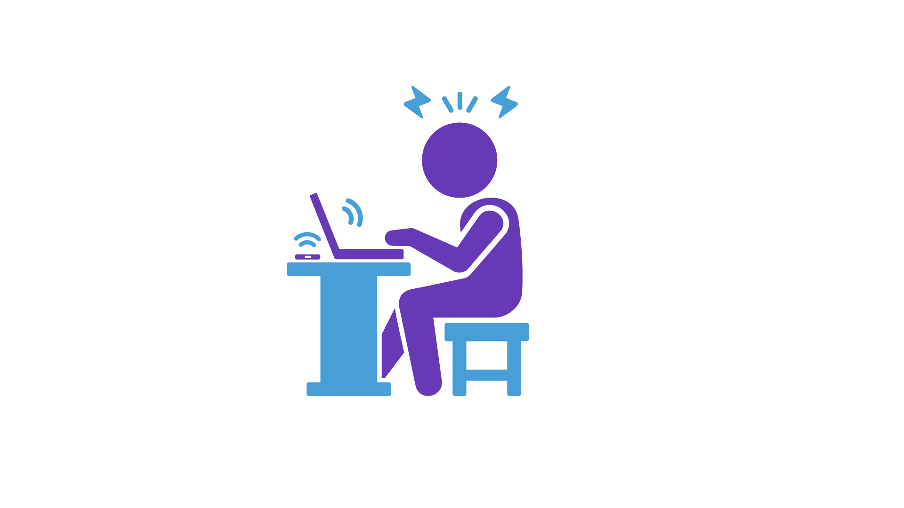

From ‘ping dread’ to burnout:

Why we must manage technology instead of letting technology manage us

Discussion paper by Business Disability Forum

May 2022

Contents

Executive summary and introduction 3

Background: Our technologies, our connections, our minds 4

Do we let technology communicate for us? 6

Interacting or collaborating? 8

Who will dare to change first? 11

Whose fault is burnout? 15

The six workplace stressors 17

Endnote: Working with wellbeing 18

Appendix: A summary of key considerations for employers 19

# Executive summary and introduction

During June 2021 and January 2022, we had a series of conversation with our members and some of their employees on topics related to work and health. Some of these conversations and discussion groups led to the development of our Including Carers Forum and a formal response to the Government’s consultation on flexible working. During this period, office-based workers had been working at home for around a year due to the pandemic; yet they were still trying to navigate their ‘new’ work related routines and preferences, and their employers were still trying to define the work-related practices they wanted to retain for post-pandemic working, to re-establish the working culture of their organisation.

The most popular topics that our members wanted to discuss centred around remote working culture that they felt was being dictated by their organisation’s use of technologies and causing increased stress and anxiety to employees. In our employee forums, we heard the same.

In the following discussion paper, we take an introductory look at the following:

* Our general approach and use of communication-based technology in our lives.
* How this is then replicated in our working environments.
* The stress and anxiety people told us they are feeling by organisations not managing use of technology effectively.
* How workplace stress becomes burnout (and how burnout is now defined).
* The employer’s responsibility to prevent burnout.

The questions we ask throughout this paper have been designed for organisations to have discussions internally to identify the technology and workplace related stressors in their organisations, and to challenge their thoughts about what ‘good’ productivity, interactions, and communication means to them.

We also share some insights from inclusion and employee wellbeing leads and employees, about the use and suggested over reliance of email and technology for how we have become used to working. We also share some key statistics about technology, workplace wellbeing and productivity, and we reaffirm the health and safety parameters that employers should be using to ensure the mental and psychological health of their employees at work. To help us with this journey, we ‘tell a story’ throughout the pages to help us reflect on our comforts and discomforts with the potential for changing the way we communicate with one another at work.

All quotations, unless otherwise referenced, are from employers and employees that we spoke to between July 2021 and January 2022. Thank you to everyone who shared their thoughts and experiences with us.

# Background: Our technologies, our connections, our minds

In 2021, office-based workers had been working at home for most or part of the time for over a year due to the pandemic. The queries we received to our advice teams and the discussions we were having in our policy and research forums identified some common themes:

* Business needed to respond and wanted to support the changing needs, concerns and ‘news ways of living’ of their customers, clients, and the users of their services.
* Businesses needed to ensure their workforces had everything they needed to be ‘positive’ and helpful for their client base and to get through the work they need to do. This includes adjustments (to remove a disability or health related barrier in an employee’s job), but the most common statement we heard was “How do we make this as **easy** as possible for staff?”
* Businesses wanted to ensure employees remained productive and progressed as the ‘physical’ and ‘in person’ office environment had been somewhat ‘taken away’ by covid restrictions.
* Managers were becoming increasingly eager to provide mental health and wellbeing support for employees that were effective.

Workplace technology was not new to our working lives during the pandemic. However, businesses and employees have said the way their workplace communicates has shifted to rely on email and apps more; common examples were, using email as the main means of communication, and the use of apps because of the need to share important, covid related updates to a lot of people very quickly. Given that we have needed ways to connect to one another at a similar pace even when most of us have not been in the same physical working location, perhaps this is natural – inevitable even. However, we heard in our discussions that little consideration has been given to what the consequences of our use of workplace technology has been. This increased speed and the expectation to have many apps open and appear ‘online’ must take its toll on workers in some way. The discussions we have been having during the last year, have indicated that this toll is on our mental wellbeing.

Therefore, in the summer of 2021, we started a series of ‘workplace health and wellbeing conversations’ with our businesses and their employees. These discussions were informal and were for the purpose solely of understanding why, as mental health has been very much ‘on the agenda’ for many businesses long before the pandemic, employees are suffering from burnout and, as research increasingly shows, workplace stress is at an all time high in workforces.

We set discussion topics for these conversations, but the issues that almost every business and employee wanted to discuss was the impact email and ‘workplace tech’ was having on how they feel about work. The technological demands of workplaces were causing consistent anxiety, increased distress, and were disengaging employees from the jobs and workplaces where they had [previously] enjoyed being. In numerous conversations, we also heard that employees “**dreaded**” going on annual leave, because of the emails they knew they were receiving while they were away, and the stress they would feel when they came back and would have to return to reading and dealing with them all.

Among all of this, Business Disability Forum saw that one key element of employment law was consistently unacknowledged: **burnout is caused when an employer does not manage the working environment**. Too easily, mental ill health and burnout appeared to attract a narrative of it being the employee’s ‘fault’. The **employee** is ‘off sick’ or the **employee** is given information on ‘being resilient’ and ‘managing mental health’.

In this discussion paper, we highlight some of the key concerns that emerged from our workplace health discussions about technology, and we also reintroduce the health and safety at work landscape which employers should use to ensure their employees to not become mentally unwell because of workplace related conditions and environments.

**What do we mean by ‘workplace tech’?**

**This is any technology the employer provides for and mandates use of in an employee’s job. This includes software packages and the apps within them. This may include email, instant messaging apps, project management tools, internal chat channels. It also includes devices such as laptops, tablets, phones, smart speakers.**

**It does not include social media or the apps and tech devices that an individual chooses to use outside of their job.**

# Do we let technology communicate for us?

**You are the new Director of Innovation and Entrepreneurship of a global organisation who needs to work with 26 different government agencies and 500 universities to disseminate a fixed amount of funding effectively within a fixed, given timeframe. You arrive at your office, on your first day.  
  
You have your smartphone, your laptop, a tablet and you sit at desktop computer too. Statistically, you probably also have a smartwatch, a VR device, and a smart speaker too.  
  
You are connected for productivity. Thanks to a voice activated Bluetooth earpiece, you can also be available while you commute, walk for a short trip to the washroom (where, statistically, you also take calls and send emails), or while getting your (quick) lunch.   
  
It’s easy. People can reach you, and you can reach them. Any time. Day or night. It’s good. You are switched on. You are connected. It makes everything easier.**

Some key statistics[1]:

* UK households have around **8** internet enabled devices in their household.
* **48 per cent** of people text members of their family who lives in the same home where both are at home at the same time.
* A further **45 per cent** make **phone calls** to them, and **13 per cent** **video call** them – while they are all at home, in the same house.

Research reveals our workplace tech related behaviours:

* Desk-based workers generally send around **126 emails** a day – 1 every 4 minutes.
* We are checking our inboxes between **77 and 400 plus** times a day.
* More **than three hours** of our working days is pent sending emails.

It is no wonder the CEO of a technology firm said their day is full of “**small constant interruptions**, every day”.[2]

How does the above reflect how communicating with one another has developed in your workforce? Although we may have legitimate reasons for why people communicate by email and Instant Message at work particularly, employees also said it nevertheless reinforces a “**demand and expectation**” to be “**switched on all the time**”.

# Interacting or collaborating?

# 

**Your new job as Director of Innovation and Entrepreneurship is going well.**

**It’s a Tuesday morning. You prepare to head to work as usual. But you hear from your Chief Technology Officer that the office has to be closed temporarily. Your organisation’s IT network has a virus and the whole network is affected. It should be fixed soon, though.**

**A week passes by. There are still no emails coming in or going out of the organisation. Security protocols prevent staff from using personal email accounts.**

Many more people than ever are working remotely from their teams at the same time as many continue to experience temporary and permanent changes to the way they do their job. From our discussions with employees and employers, this combination creates the perception that employees need to show, ‘Here I am, I am working hard, I am needed’. One of the ways employees do this, is to increase their ‘visibility’ via the communications they send. It shows they are working hard, they are ‘producing things’, and therefore, they must be being productive.

However, research actually shows that, although people find interacting easier than ever:

* “Value creating productivity” is **decreasing**;
* The quality of engagement is **deteriorating**; and
* We have more **low-value** interactions and outputs than ever before.

These “low value” activities **sap employees’ energy** and create cultures of **increased ‘information overload’.** Perhaps this is why 80 per cent of senior leaders are currently considering or already implementing changes to how they organise internal meetings and communications.[3]

**Six weeks without email**

**It has now been six weeks. Six weeks without sending or receiving an email.   
  
To ensure the virus that has shut down your network does not spread, anything with a chip – computers, printers, laptops – are destroyed. There is an “existing information pipeline” of how people communicate and how information is generated, and you are “out of the loop”. Or are you?**

The story we have been following so far is told in the opening pages of Cal Newport’s “A World Without Email”.[4] When it is told to office-based workers, there are a diverse range of emotions, ranging from fear and severe anxiety from the ‘what if this happened to me’, and others smile and feel liberated that they would be free from the demands of their technology. One person even said they feel “**hope**” that there is a possibility that we may be able to “**smash up and reimagine** **what** **working well, enjoying work, and producing well instead of just ‘being productive’**” would mean for them.

For this Director, six weeks without email and pings of workplace technology did not bring down his organisation. It made him better at his job.

* ‘Quick’ emails to ask colleagues questions were no longer an option. He had to phone people or walk to their desk. He also had to better understand what the remit of people’s job was and who was responsible for what. **Contact lists** and records of people within the organisation’s various networks had to be organised. They could not look up a contact on their own or internal email contact lists.
* Longer blocks of time were needed to **arrange meetings**. Without email or calendar requests, meetings needed to be scheduled carefully, sometimes by contacting everyone who needed to be at that meeting. Talking to everyone to arrange the meeting meant a better shared understanding of what the meeting was for, what they needed to achieve by the end of it, and what people needed to take part in the meeting (adjustments, for example). This level of organisation meant meetings were more effective – and shorter.
* By talking and contacting people individually more, he **got to know his own workforce** and his clients better. This deepened relationships and built trust.
* The way he found out information changed. There was no social media access, and he could not access email bulletins from mailing lists. If he wanted to know what was going on in an office or an organisation that day, he contacted them directly to find out. We do not really need a lot of the information we ‘sign up to’. This new approach meant that he was **only getting the information he needed** when he actually wanted it.
* Not having emails to check **“opened up cognitive downtime”**. This was time to think, write, be creative, and develop new ideas without constant email and Instant Message ‘pings’

# Who will dare to change first?

Our current approach to email and work-based technologies relies on everyone else behaving in the same way. We have to be ‘switched on’ because most others we work with are also ‘switched on’. We are fuelling one another’s work-based stress.

Emails have become a substitute for well-designed information flow processes, good use of meetings, effective role definitions, and getting to know the people in our workforces. Part of this is employers knowing who defines when they are being successful and productive in their job, and what outputs the people monitoring their outputs and performance are looking out for from them.

Many employees told us the pressure comes from “**competing demands**” from different people in their organisation at the same time. This included feeling as though the emails they produced were being noticed by colleagues, but the work they produced were being watched by their immediate managers, whereas contributions (in terms of thoughts or new ideas) were being watched by managers above their immediate managers. On top of these, being a ‘good member of the team’ meant taking part socially in an internal social media channel. They are told internally that this builds rapport and good working relations – but it is yet another demand from another internal audience and from another tech platform.

We therefore need to better **identify the demands** our employees are feeling, and where (and who) those demands coming from. Some of those demands may be real and necessary, real and unnecessary, or not real and entirely perceived by the stress and pressure the employee is feeling generally. Identifying the latter two, means we can also remove them from employees and decrease the demands they feel.

**Key questions for employers**

The constant flow of notifications and information relies on each of us feeding and generating it for one another. However, some technology and business management thought leaders say the use of email is finite: **a world without email is coming.[5]**

* How does hearing that ‘a world without email is coming’ make you feel?
* What would it mean for you not to have email in your job?
* What does it cause you to reimagine in terms of how you communicate and how you do your job?
* How would you work with another organisation who does not use email?
* What would happen to your business or organisation if you went into work tomorrow and there was no email for six weeks? Would your organisation continue to be successful and profitable, or would everything ‘grind to a halt’?
* What do your answers to the above cause you to consider about the infrastructure of how your organisation communicates, shares information, and operates as a business?

**(Not) managing technology**

The below are excerpts from some of our conversations with members during the last year about how they feel about wellbeing and attitudes to email and tech-based communications at work:

* Some people said they “**dreaded**” the Christmas and New Year break, because the sheer weight of their workloads had meant they could not finish everything they needed.
* Some said they “**felt sick**” and, again, “**dreaded**” coming back to work in January after the Christmas break because they knew “what is waiting” for them when they return (more work and more emails).
* Employees said they want “**more humanity**” from senior leaders, not a “**productivity show**”. One person said they would prefer to see their senior leaders “**taking a lunch break** than replying to emails on their phone as they walk to the toilet”. This would help prevent the employees feeling, in one’s person’s words, “**Is it just me who is overwhelmed?**”
* Some people said they felt “**punished**” for taking annual leave or going on holiday because of the number of emails and notifications that they must clear before they go and that are waiting for them when they return. **No one we spoke to had their workload adjusted to take account of their annual leave.**
* Someone referred to “**ping dread**” – the “**anxiety**” they feel when they are tyring to work on something “and another email pops up”.
* People said they wanted more “**kindness**” in the expectations their managers and organisation have of them.

Research backs up what we heard in our conversations:

* Our ‘switched on’ tech culture is creating a pressure to succeed – and what “succeed” means is complex. **60 per cent** of 18–24-year-olds feel stressed by the **pressure to succeed.**
* **Up to 90 per cent** of fit notes from GPs at the end of 2021 were for **stress related illnesses.[6]**
* **79 per cent** of workers regularly experience **work related stress**. How many do not experience work related stress? **One per cent**.[7]
* Only **1 in 6** say their employers are supporting their mental wellbeing – i.e., providing the interventions and solutions that **actually work** and **makes things better for them**.[8]
* Internet searches for “**occupational burnout**” have **increased by 2,500 per cent** since 2015.[9]
* During the last 12 months, **25 per cent** of employers feel they have **reached “psychological breaking point”.**[10]

# Whose fault is burnout?

There have been calls for legislation to provide the “Right to Disconnect”. The campaign defines this as “a law guaranteeing UK workers the right to digitally disconnect from work outside of normal hours”. The campaign pitches this as a human rights issue and not allowing employees to do this “is “a major trigger and accelerator to mental ill health”.[11]

Legislation is being called for, because employees in our workforces are becoming unwell and businesses and employers are not effectively resolving the issue.

The ‘self-help’ and ‘resilience’ narratives about managing workplace, manging our wellbeing, and ‘looking after our mental health’ when employees are stressed, overwhelmed by work and experiencing burnout are somewhat accusatory. They make out that this is the employee’s fault because they need to ‘build resilience’ or ‘manage their workload’.

To understand whose fault burnout is, we must first understand what it is. Such is the increase in workplace related burnout, that the World Health Organisation (WHO) re-established the definition in 2019. The definition of “burnout” according to the WHO:

**“****Burnout is a syndrome conceptualized as resulting from chronic workplace stress that has not been successfully managed. It is characterised by three dimensions:**

**1) feelings of energy depletion or exhaustion;**

**2) increased mental distance from one’s job, or feelings of negativism or cynicism related to one's job; and**

**3) a sense of ineffectiveness and lack of accomplishment.”**[12]

This contrasts our approach to when employees are experiencing burnout – we give them tools to help them ‘be better’ about ‘managing themselves’. Instead, the definition of burnout asserts that it is caused by the employer, when the employer has not managed workplace stress effectively. The definition offers the perspective that burnout is not employees’ fault; this definition shows that it is not.

Burnout is when the anxiety experienced at work becomes more increased and regular to the point that is affects the person’s function and wellbeing. It builds up, adding layer upon layer of increasing stress and anxiety:

* Work related anxiety is experienced when work becomes demanding; then
* This anxiety becomes increased, regular, and continuous; then
* This level of anxiety causes “clinically significant impairment in a person’s functioning and wellbeing”. This is burnout.

# The six workplace stressors

The WHO says,

“Intrinsic demands of the job, individual susceptibility, and poor work organisation contributes to increased stress in health workers. Prolonged job stress may cause burnout, chronic fatigue, absenteeism, high staff turnover, reduced patient satisfaction, and increased diagnosis and treatment errors.”[13]

The UK’s Health and Safety Executive therefore defines six key areas that can lead to work related stress if employers do not manage them properly. They are:

1. **Demands** – when employees struggle or are unable to cope with the demands of their job. This includes workload, work patterns, and the working environment.
2. **Control** – when employees struggle or are unable to control the way they do their work.
3. **Support** - when employees do not receive enough information and support from their employer.
4. **Relationships** – when employees are having trouble with relationships at work or are being bullied.
5. **Role** – when employees do not fully understand their role and responsibilities.
6. **Change** – when employees are not engaged with, when a business is undergoing change.

Therefore, employers should answer the following questions:

What measures are in place to identify where the above work-related stressors are occurring for employers?

How is the way your organisation communicates and uses workplace contributing to the above stressors for employees?

What procedures are in place to manage or remove these stressors?

# Endnote: Working with wellbeing

We have more tech solutions, gadgets, and software-embedded interventions than ever to choose from and be ‘wowed’ by, that promise to make us quicker, better, more valuable as producers of various visible outputs that (we believe) will prove our worth to our employer.

But ultimately, employers need to consider, respond to, and resolve the following question:

**How can the communication technologies you use create healthier, happier working environments for your employees not just to work, but to work with wellbeing?**

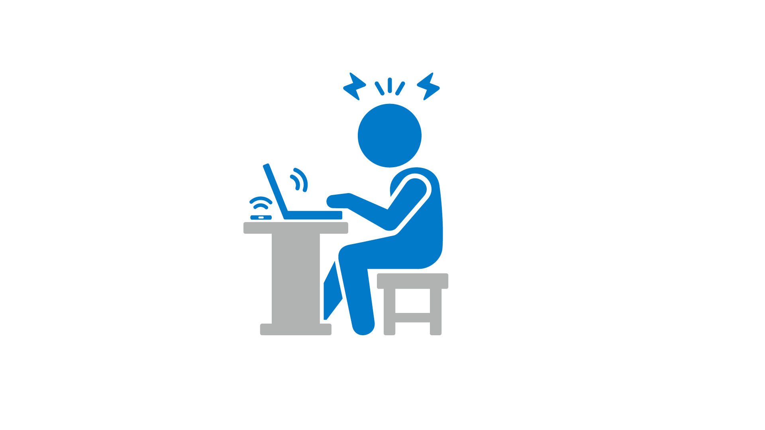

# Appendix: A summary of key considerations for employers

The following is a summary of the questions throughout this discussion paper which we ask employers to consider.

**If your organisation no longer had email**

* How does hearing that ‘a world without email is coming’ make you feel?
* What would it mean for you not to have email in your job?
* What does it cause you to reimagine in terms of how you communicate and how you do your job?
* How would you work with another organisation who does not use email?
* What would happen to your business or organisation if you went into work tomorrow and there was no email for six weeks? Would your organisation continue to be successful and profitable, or would everything ‘grind to a halt’?
* What do your answers to the above, cause you to consider about the infrastructure of how your organisation communicates, shares information, and operates as a business?

**Identifying occupational stressors to prevent burnout**

What measures are in place to identify where the above work-related stressors are occurring for employees?

How is the way your organisation communicates and uses its workplace contributing to the above stressors for employees?

What procedures are in place to manage or remove these stressors?

**Overall key strategic question for organisations**

* How can the communication technologies you use create healthier, happier working environments for your employees not just to work, but to work with wellbeing?

About Business Disability Forum

Business Disability Forum is a not-for-profit membership organisation which exists to transform the life chances of disabled people, working through and with business to create a disability-smart world.

Our 450+ Members and Partners represent a huge cross sector of UK and global business, employing an estimated 20% of the UK workforce and 8 million people worldwide. We provide them with a wealth of practical advice and support, and use their evidence base to influence government and policy makers to help shape disability policy that works.

Business Disability Forum

Nutmeg House

60 Gainsford Street

London SE1 2NY

Tel: +44-(0)20-7403-3020

Email: policy@businessdisabilityforum.org.uk

Web: [www.businessdisabilityforum.org.uk](http://www.businessdisabilityforum.org.uk)

**Business Disability Forum is a company limited by guarantee with charitable objects.**

**Registered charity number:** 1018463.

**Registered Office:** Nutmeg House, 60 Gainsford Street, London SE1 2NY.

**Registered in England under Company Number:** 2603700

1. Statistics in this paragraph are from a study by Aviva in January 2020.
2. All figures and quotations in this paragraph are cited in Newport, C. (2021) “A World Without Email: Reimagining Work in an Age of Communication Overload” (published by Penguin Random House).
3. Research conducted by McKinsey, 2022.
4. Newport, C. (2021) “A World Without Email: Reimagining Work in an Age of Communication Overload” (published by Penguin Random House).
5. Newport, C. (2021) “A World Without Email: Reimagining Work in an Age of Communication Overload” (published by Penguin Random House).
6. Statistics from NHS England, 2022.
7. Research by Perkbox in 2022.
8. Simon Brittz (2022) “Employee burnout: Addressing the silent epidemic gripping the nation” in “Elite Business” [online] on 7 January 2022.
9. Simon Brittz (2022) “Employee burnout: Addressing the silent epidemic gripping the nation” in “Elite Business” [online] on 7 January 2022.
10. Simon Brittz (2022) “Employee burnout: Addressing the silent epidemic gripping the nation” in “Elite Business” [online] on 7 January 2022.
11. <https://righttodisconnectuk.com/>
12. The World Health Organisations ICD-11 for Mortality and Morbidity Statistics, section QD85, “Burnout”.
13. World Health Organisation, “Occupational stress, burnout and fatigue” at <https://www.who.int/tools/occupational-hazards-in-health-sector/occup-stress-burnout-fatigue> [Accessed May 2022]